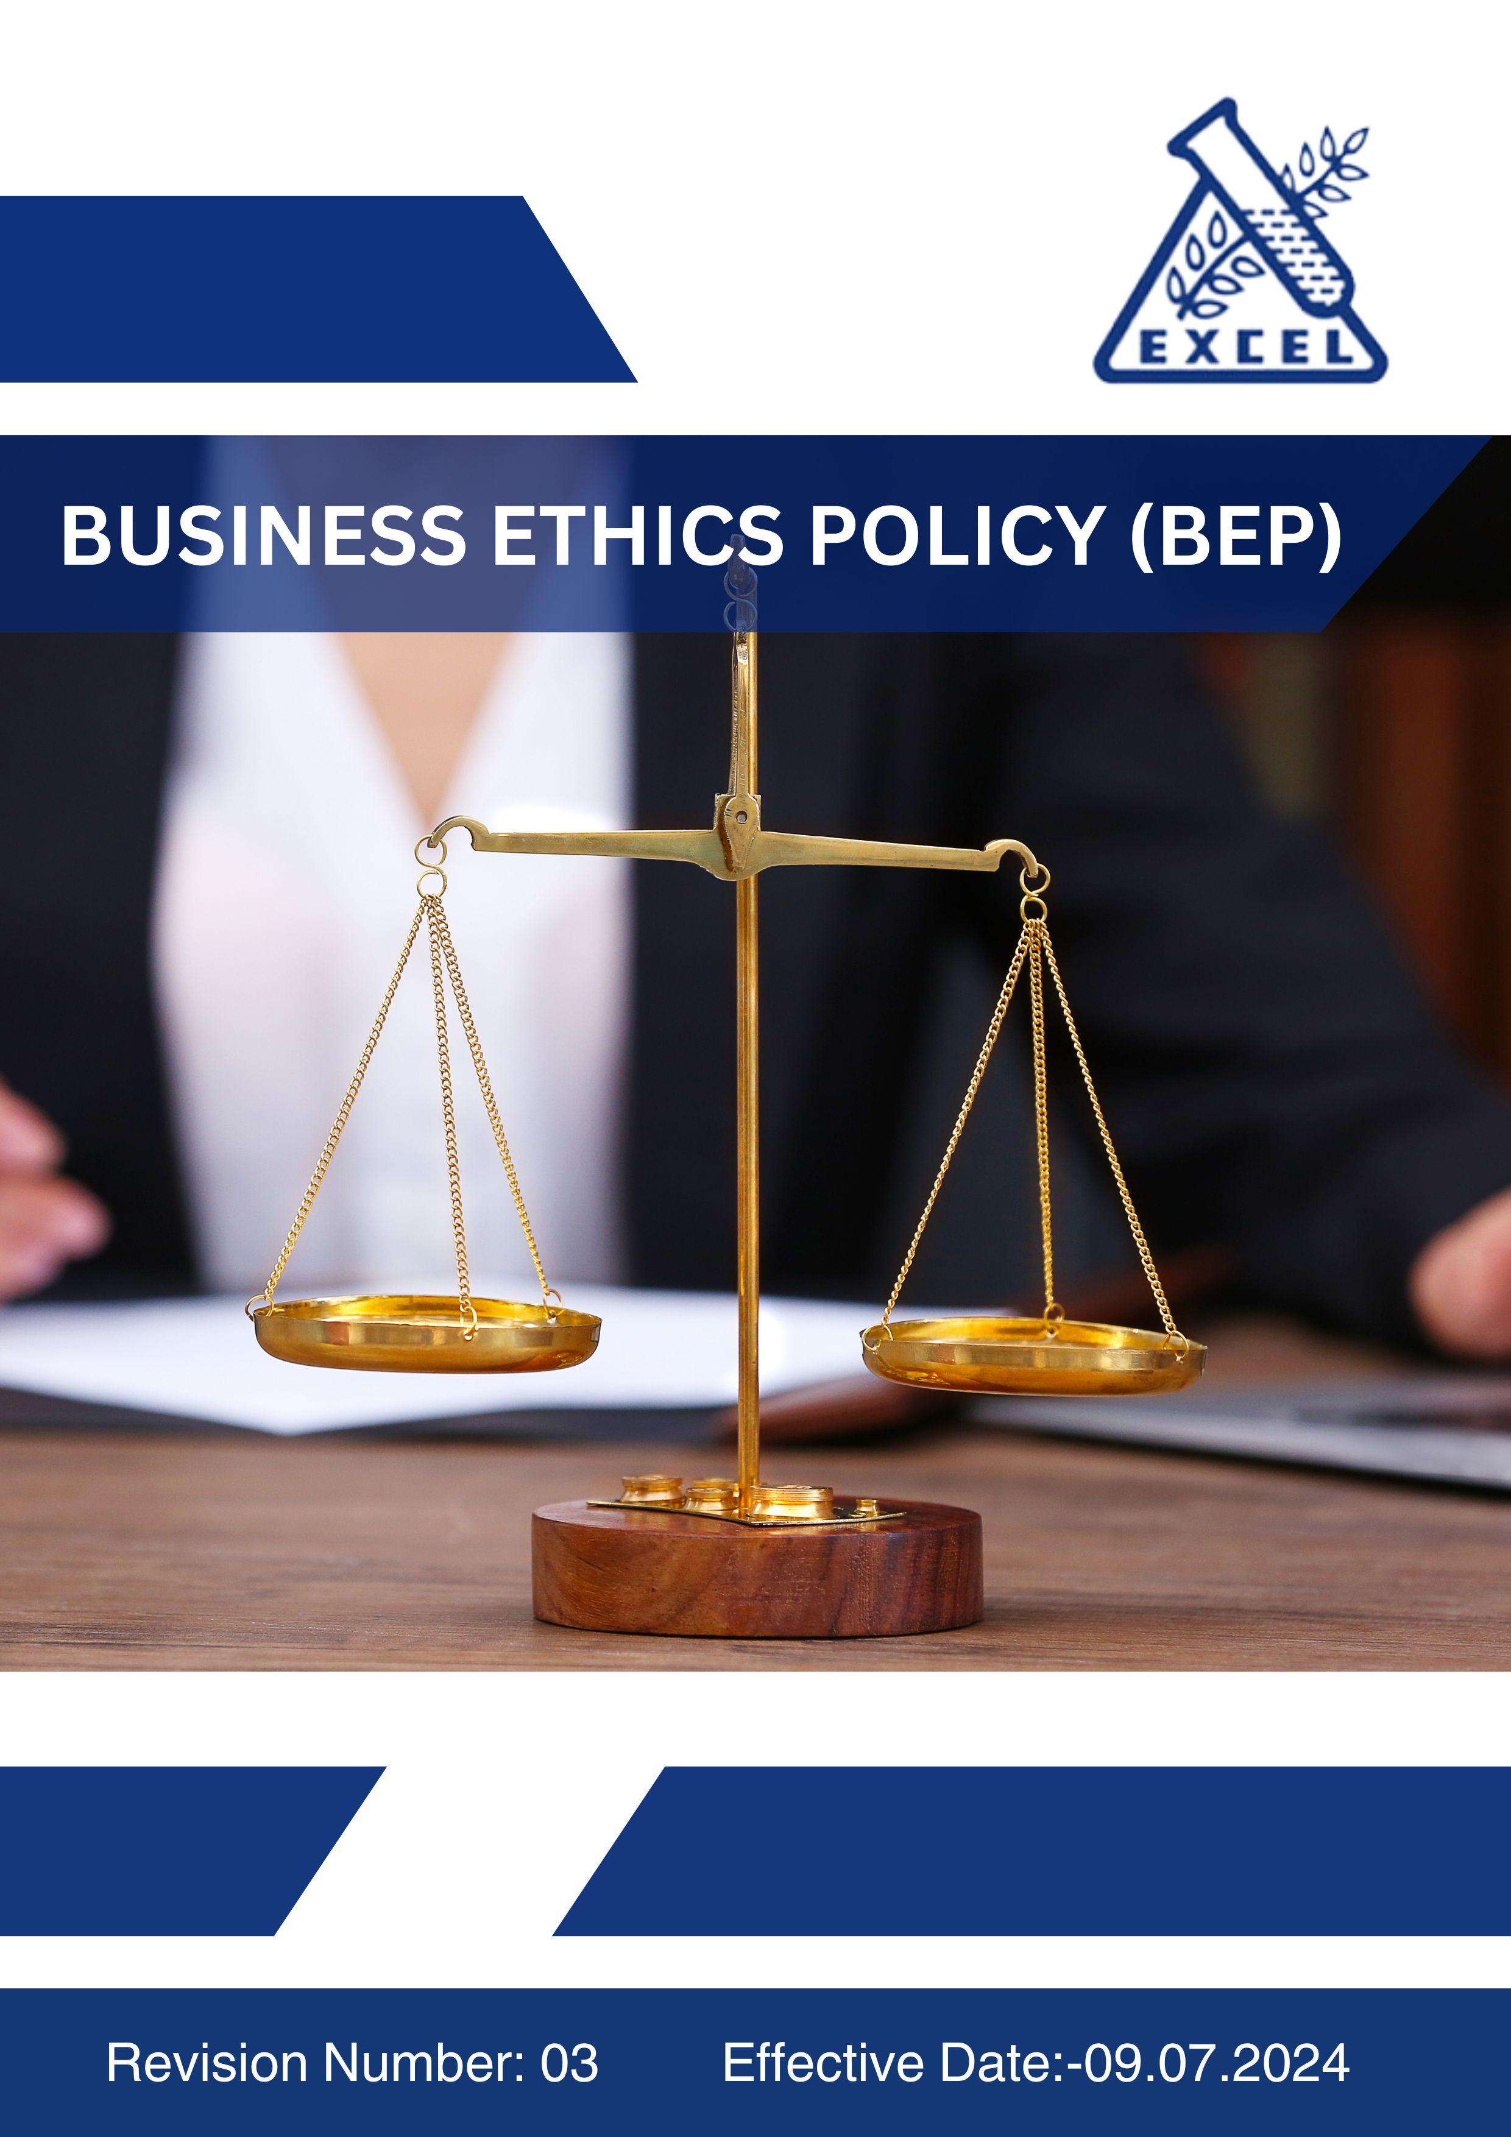

OBJECTIVES:
Excel Industries Ltd is committed to maintaining the highest standards of ethics and integrity in all aspects of our business operations. This policy outlines our stance on corruption, anticompetitive practices, conflict of interest, fraud, money laundering, sensitive transactions and responsible information management. It applies to all employees, contractors, and associates of Excel Industries Ltd.

SCOPE:
This policy applies to all business units and functions within Excel Industries Ltd, including manufacturing, research and development, purchase, sales, marketing, logistics, and corporate offices. It also applies to the contractors and their workmen, service providers, stakeholders, working inside the premises of Excel Industries Limited. This policy is applicable across all operating sites of Excel Industries Limited as listed below.

Sr. No. | Site Name | Location / Address
 | Corporate Head Office | 184/87, S.V. Road, Jogeshwari (W), Mumbai, Maharashtra 400102, India.
 | Roha Manufacturing Site | Plot No. 112, 20/1, OS-2, MIDC, Dhatav, Roha, Raigad, Maharashtra 402116, India.
 | Lote Manufacturing Site | D-9, MIDC, Lote Parshuram, Ratnagiri, Maharashtra 415722, India.
 | Visakhapatnam Manufacturing Site | Plot No. 15 & 15A, APSEZ, Atchutapuram, Vishakhapatnam, Andhra Pradesh, 531011, India
 | Excel Bioresources Limited,  Subsidiary | 184/87, S.V. Road, Jogeshwari (W), Mumbai, Maharashtra 400102, India.
 | Kamaljyot Investments Limited,  Subsidiary | 184/87, S.V. Road, Jogeshwari (W), Mumbai, Maharashtra 400102, India
 | Excel Rajkot C&D waste recycling Private Limited, Subsidiary | 184/87, S.V. Road, Jogeshwari (W), Mumbai, Maharashtra 400102, India

POLICY STATEMENT :
(The Policy statement will be uploaded on website and will be printed for posters, cards etc for the purpose of communication).
Excel Industries Limited, a responsible manufacturer of Industrial chemicals, Intermediates, specialty chemicals, agricultural chemicals and pharmaceutical products is committed to provide adequate resources related to Business Ethics and Ethical Behavior, promoting a healthy atmosphere inside the company and protecting the rights and well-being of our employees and stakeholders across all its functions and locations.
To achieve the same, we will ensure the following:
- Zero Tolerance towards any form of corruption, including bribery, fraud, money laundering, sensitive transactions and embezzlement.
- Compliance of all employees with all applicable anti-corruption laws and regulations.
- Prohibition from offering, giving, or receiving gifts, hospitality, or benefits that could influence their routine activities, work and their business decisions.
- Commitment of the company and its Management to Fair and Ethical Competition in the marketplace.
- Non engagement of any employee in any practices that restrict competition, including but not limited to price-fixing, market division and bid-rigging.
- Compliance of all employees with applicable antitrust and competition laws.
- Adequate training will be provided to all the concerned employees to ensure understanding and compliance of the Ethics Policy.
- The company through its practices and policies protects the confidentiality and integrity of all business-related data, intellectual property, documents of eternal origin, personal data of employees, customers and partners.
- Employees must comply with all applicable information / data privacy laws and regulations.
- Employees must follow all company policies and procedures related to information security to its protect against unauthorized access, disclosure, alteration, or destruction.
- Employees must report suspected or actual instances of corruption, anticompetitive behavior, and breaches of information security or data privacy to the respective HR Heads or Members of ethics committee.
This policy will be reviewed in each Management Review Meeting, monthly for its continuing suitability to the organization’s current business and to ensure its relevance and effectiveness. We will make this policy available to our customers and stake holders, wherever required.

QUALITATIVE TARGET:
The Top Management of the company is committed to provide all organizational support for achieving qualitative Business Ethics targets, through the following directives:

1. Corruption
- Foster a company-wide culture of honesty, integrity, and transparency in all operations and business decisions.
- Eliminate all forms of corruption, bribery, embezzlement, and unethical inducements within company operations and the value chain.
- Promote zero tolerance for bribery or unethical practices in any form, whether internal or external.
- Strengthen ethical decision-making through regular communication, awareness, and leadership commitment.
- Ensure transparency and accountability in financial and procurement transactions.
- Encourage employees and third parties to report unethical conduct without fear of retaliation.

2. Anticompetitive Practices
- Promote fair competition and ensure that business growth is driven by innovation, quality, and ethical practices.
- Build awareness among employees regarding antitrust laws and fair business competition principles.
- Prevent any form of price-fixing, bid-rigging, or market allocation through strong internal compliance controls.
- Encourage ethical marketing and transparent business dealings with customers and partners.
3. Fraud
- Establish a fraud-free organizational culture built on trust, transparency, and ethical behavior.
- Strengthen internal control systems to prevent and detect any form of fraud or financial irregularity.
- Encourage employees to act with integrity and report suspicious activities immediately.
- Promote zero tolerance for misrepresentation, falsification of data, or misuse of company resources.
- Enhance awareness and vigilance through regular training, audits, and compliance programs.
4. Conflict of Interest
- Promote a work environment of impartiality and ethical judgment free from personal or financial bias.
- Encourage transparent disclosure of any relationships or interests that could influence professional decisions.
- Build a culture where organizational interests take precedence over personal gains.
- Ensure equitable decision-making in procurement, hiring, promotions, and partnerships.
- Reinforce the importance of integrity, independence, and objectivity in all business dealings.
5. Money Laundering
- Promote transparency and accountability in all financial transactions and relationships.
- Conduct due diligence and background checks for third-party vendors, customers, and partners.
- Strengthen awareness of anti-money laundering obligations among employees at all levels.
- Foster a corporate culture where compliance with legal and financial regulations is non-negotiable.
6. Sensitive Transactions
- Ensure all transactions involving gifts, entertainment, sponsorships, and donations are conducted ethically and transparently.
- Promote clear documentation and justification for all sensitive or high-risk transactions.
- Prevent conflicts of interest or misuse of authority in decision-making involving external entities.
- Reinforce management oversight for sensitive financial and contractual activities.
- Build stakeholder trust through openness and consistent application of ethical standards.

7. Responsible Information Management
- Promote a culture of confidentiality, integrity, and respect for data privacy across all functions.
- Ensure all employees handle information responsibly and in compliance with data protection laws.
- Protect intellectual property, trade secrets, and personal data from unauthorized access or misuse.
- Strengthen cybersecurity awareness and accountability among employees and partners.
- Integrate information security best practices into daily operations and business systems.

Quantitative Targets
We have set the baseline year as FY 2021-22 for the below Business Ethics KPIs. All targets are to be achieved by 2034-35 unless otherwise stated.

1. Corruption and Bribery
- Maintain zero (0) incidents of corruption, bribery, or unethical financial transactions diligently every year.
- Conduct annual anti-corruption training for 100% of employees by 2034-35.
- Include anti-corruption clauses in 100% of supplier and vendor contracts by 2034-35.
- Conduct annual third-party due diligence audits covering 100% of high-risk vendors by 2034-35.
- Maintain 100% disclosure and approval of gifts and hospitality transactions by 2034-35.

2. Anticompetitive Practices
- Ensure 100% compliance with applicable antitrust and competition laws every year.
- Conduct annual fair competition and compliance training for 100% of employees by 2034-35.
- Maintain zero (0) regulatory penalties or legal actions related to anticompetitive behavior every year.
- Perform internal audits on competition compliance at 100% of sites annually by 2034-35.
3. Fraud Prevention and Detection
- Maintain zero (0) confirmed incidents of internal or external fraud every year.
- Conduct quarterly internal audits to detect and mitigate potential fraud risks.
- Ensure 100% of employees in finance, procurement, and administration receive fraud awareness training annually by 2034-35.
4. Conflict of Interest
- Achieve 100% compliance with conflict-of-interest disclosures by employees in key decision-making roles by 2034-35.
- Conduct annual conflict of interest declaration reviews and updates for all senior and managerial employees by 2034-35.
- Provide training on ethical decision-making and conflict management to 100% of employees by 2034-35.
- Maintain zero (0) unreported or unresolved conflict of interest cases every year.
5. Money Laundering and Sensitive Transactions
- Maintain zero (0) incidents of money laundering or suspicious financial activity by 2034-35.
- Ensure 100% of financial and procurement staff receive AML (Anti-Money Laundering) training annually by 2034-35.
- Conduct due diligence on 100% of high-value financial transactions by 2034-35.
- Ensure zero (0) non-compliance cases related to donation, sponsorship, or high-risk transactions by 2034-35.
6. Responsible Information Management
- Maintain zero (0) data breaches by 2034-35.
- Achieve 100% compliance with data protection laws (e.g., GDPR) by 2034-35.
- Conduct annual data privacy and information security training for 100% of employees by 2034-35.
- Implement regular cybersecurity audits and risk assessments at 100% of operational sites by 2034-35.
- Ensure 100% encryption and secure access controls for sensitive business and employee data by 2034-35.

Implementation and Accountability:
- Compliance: Ensure compliance with all relevant laws, regulations, standards related to Ethics and Governance.
- Training: Provide regular training and awareness to employees on Ethics policy, practices, and responsibilities.
- Performance Monitoring: Set measurable Business Ethics performance goals and regularly review progress towards achieving these goals.
- Transparency: Report our Business Ethics performance and progress in a transparent manner to stakeholders.

Governance and Responsibilities:
- Managing Director and President & COO: Oversight of the Business Ethics policy and performance.
- Vice President Operations: Development and implementation of Business Ethics strategies.
- Management Review Meeting (MRM) committee: Responsible for monthly review of the Policy at all sites to assess progress and make necessary amendments as required. Evaluates Business Ethics performance metrics and KPIs. Ensures cross-functional coordination on Business Ethics initiatives.
- Ethics Committee: Ensure Policy implementation, monitors compliance and reports to the Board. Handling and resolution of ethics related complaints, development and implementation of HR strategies and policies. Chaired by the HR Head and / or President of the company.
- Human Resources (HR) Department: Responsible for day-to-day management of Ethical practices and programs, code of conduct, training, and reporting. Ensures adherence to the policy across all functions.
- Department Heads: Ensure compliance with Ethics Policy and targets within their departments. Report progress and issues to the HR Department.
- All Employees: Expected to adhere to the Ethics Policy and report any violations or concerns.

Policy Review Mechanism:
- Review: This Ethics Policy will be reviewed monthly at all the sites during Management Review Meeting (MRM) by the committee to assess progress and ensure its effectiveness and relevance and adapting to new legal and regulatory requirements and make necessary amendments, if required.
- Performance Reporting: Regular reporting on Business Ethics performance to the MRM Committee, Board of Directors, and stakeholders through Business Responsibility and Sustainability Report (BRSR) and Annual Sustainability Report (ASR).
- Stakeholder Engagement: Continuous dialogue with stakeholders to incorporate feedback and improve our Ethical practices.

DO’s & DON’Ts
To ensure ethical governance and responsible conduct at all organizational levels, the following Do’s and Don’ts serve as practical guidelines for all Employees, Managers, Directors, contractors and external stakeholders of Excel Industries Limited.
1. Anti-Corruption and Fraud Prevention
✅ Do’s
- Report any suspicious activity, bribery attempts or unethical financial behaviour to the Compliance Officer (AVP HR) or Ethics Committee immediately.
- Maintain transparent, accurate and complete records of all financial and commercial transactions.
- Adhere to all anti-corruption laws, internal policies, and mandatory training requirements.
- Refuse gifts, hospitality, or incentives that could influence or appear to influence business decisions.
❌ Don’ts
- Do not offer, accept or solicit bribes, kickbacks or unlawful payments in any form.
- Do not falsify, conceal, or misrepresent financial records or information.
- Do not engage in fraudulent dealings, embezzlement or misappropriation of company assets.
- Do not ignore or withhold information related to suspected corruption or fraud.

2. Conflict of Interest Management
✅ Do’s
- Disclose any personal, financial, or family relationships that may create a conflict of interest.
- Seek prior approval from senior management before engaging in any external business or employment.
- Follow the company’s procedures for reporting and resolving conflicts of interest.
❌ Don’ts
- Do not make business decisions for personal benefit or in favour of relatives or friends.
- Do not engage in outside employment, consultancy or partnerships that compete with Excel Industries Limited.
- Do not use company resources, confidential information or position for personal gain.

3. Money Laundering Prevention
✅ Do’s
- Report any unusual, suspicious or complex financial transactions to the Compliance Department.
- Conduct due diligence and background checks before establishing relationships with new customers, suppliers or agents.
- Maintain accurate documentation for all financial dealings and ensure transparency in fund flows.
❌ Don’ts
- Do not approve or process transactions without clear business purpose or supporting documentation.
- Do not ignore red flags related to suspicious payments or third-party behaviour.
- Do not engage in structuring or concealing transactions to evade reporting or regulatory requirements.

4. Anti-Competitive Practices
✅ Do’s
- Compete fairly and promote innovation, quality and ethical practices in the marketplace.
- Comply with all applicable antitrust and competition laws.
- Maintain transparency in pricing, negotiations and contractual dealings.
❌ Don’ts
- Do not engage in price-fixing, bid-rigging, market allocation or cartel activities.
- Do not discuss or share confidential pricing, production or strategy information with competitors.
- Do not misuse market position to gain unfair competitive advantage.

5. Information Security and Data Protection
✅ Do’s
- Follow all company information security and data protection policies.
- Use strong passwords, restricted access, and approved company systems for handling data.
- Immediately report any data breach, phishing attempt or unauthorized system access.
❌ Don’ts
- Do not share confidential company information with unauthorized personnel.
- Do not store or transmit sensitive business data on personal devices or unapproved applications.
- Do not click on suspicious links, attachments or unsolicited emails.

Failure of COMPLIANCE:
Excel Industries Limited adopts a zero-tolerance approach toward any violation of the Business Ethics Policy, while ensuring that disciplinary actions are proportionate to the nature and severity of the violation.
If an employee or stakeholder is found to have breached this policy, the company will take corrective action in line with the seriousness of the misconduct:
- Minor Violations:
- Instances of unintentional or first-time non-compliance (e.g., minor procedural lapses, delayed disclosures, or unintentional oversight) will typically result in verbal counseling, formal warnings, or retraining to reinforce awareness and compliance.
- Moderate Violations:
- Repeated or negligent violations (e.g., conflict of interest not disclosed, misuse of company resources, or failure to follow due diligence procedures) may attract written warnings, suspension, performance penalties, or reassignment, depending on the impact.
- Severe Violations:
- Serious ethical breaches (e.g., fraud, bribery, corruption, money laundering, anticompetitive behavior, or willful data breach) will result in termination of employment or contract, and the company may initiate legal action and report the matter to regulatory authorities, if required.
All employees are encouraged to report violations or suspected unethical conduct through the company’s whistle-blower mechanism without fear of retaliation. The company ensures confidentiality, fairness, and protection for those raising concerns in good faith.
Excel Industries Limited remains committed to fostering a workplace culture where integrity, transparency, and accountability are upheld across all levels of operation.

Conclusion:
Excel Industries Limited is committed to lead by example in promoting integrity, transparency and ethical business conduct across all our operations. Through the implementation of this comprehensive Business Ethics Policy, we aim to ensure responsible decision-making, prevent corruption and unethical practices, and promote fair competition and accountability at every level of the organization.

This policy will be reviewed monthly for its continuing suitability to the organization’s current business environment. We will make this policy available to all employees, customers, suppliers, and other stakeholders, reaffirming our dedication to ethical excellence, good governance and sustainable business growth.

POLICY DISTRIBUTION RECORD:
Sr. | Department | No. of copies
1 | All Departments: Mumbai Office. | ~10
2 | All Departments: Roha Site. | ~12
3 | All Departments: Lote Site. | ~12
4 | All Departments: Visakhapatnam Site. | ~10
NOTE: The Master Copy of this Policy Document bears original signatures and a “MASTER COPY” stamp on each page. All controlled copies of this POLICY are photocopies of the signed master copy, with a “CONTROLLED COPY” stamp. All other unsigned copies, printed copies, photocopies, or electronic copies of this POLICY are uncontrolled copies.

ACCOUNTABILITY (Document Preparation):
This policy will be prepared by AM HR, Checked by GM Sustainability, reviewed by AVP HR and President & COO. The policy will be approved and signed by the Managing Director of the company.

REVISION HISTORY:
REVISION NO. | DATE OF REVISION | REASON FOR REVISION | APPROVED BY
00 | 09.07.2024 | New Document | P.N.Ghattu
01 | 03.06.2025 | Added Policy Statement and Scope for all manufacturing sites.  Added Governance, Responsibilities, Review Mechanism sections. | R.A.Shroff
02 | 25.07.2025 | Revised Qualitative targets and added Quantitative targets. | R.A.Shroff
03 | 01.08.2025 | Added Do’s & Don’ts & Employee Acknowledgement section | R.A.Shroff

Employee Acknowledgement:
I, the undersigned, acknowledge that I have read, understood, and agree to comply with the Business Ethics Policy of Excel Industries Limited.
I am aware that this policy outlines the company’s commitment to uphold the highest standards of integrity, transparency, fairness, and ethical conduct across all its operations.

I understand my individual responsibility to:
- Conduct business honestly, fairly, and in compliance with all applicable laws and regulations.
- Avoid any form of corruption, bribery, conflict of interest, or fraudulent activity.
- Respect confidentiality and ensure the protection of sensitive information and data.
- Report any observed or suspected violations of this policy, unethical conduct, or conflicts of interest to the Compliance Officer, HR Department, or Ethics Committee.
- Participate in ethics and compliance training programs as required by the organization.
I also understand that failure to comply with the provisions of this policy may result in disciplinary action, up to and including termination of employment, and may also attract legal consequences where applicable.
